**Software Requirements Specification**

**for**

Patient Stroke Prediction

**Version 1.1**

**Prepared by Artem Mercer, Vincenzo Mezzio**

**-02-**

**Table of Contents**

**Table of Contents ii**

**Revision History ii**

**1.** **Introduction 1**

1.1 Purpose 1

1.2 Scope 1

1.3 Overview 1

**2.** **General/Overall Description 1**

2.1 Product/System Perspective 1

2.2 Product Functions/Features 2

2.3 User Classes and Characteristics 2

2.4 Operating Environment 2

2.5 Design and Implementation Constraints 2

**3.** **Functional Requirements 2**

3.1 System Features 2

3.2 Preliminary Use Case Models and Sequence Diagrams 4

**4.** **Nonfunctional Requirements 5**

4.1 Performance Requirements 5

4.2 Security Requirements 5

4.3 Usability Requirements 6

4.4 Software Quality Attributes

4.5 System Requirements 6

4.6 Reliability Requirements 6

4.7 Supportability Requirements 6

4.8 Legal, Copyright, and Other Notices 6

4.9 External Interface Requirements 7

4.10 On-Line User Documentation and Help System Requirements 8

**Appendix A: Glossary 8**

**Appendix B: Analysis Models 9**

**Appendix C: To Be Determined List 9**

**Revision History**

| **Name** | **Date** | **Reason For Changes** | **Version** |
| --- | --- | --- | --- |
| <Artem, Vincenzo> | <02/18/22> | SRS preparement/Utilization | <1.1> |
| <Artem, Vincenzo> | <03/03/22> | Functional Requirement Revision | <1.2> |

# **Introduction**

The point of this project is to be able to provide patients with their own personal status using machine learning algorithms to be able to predict the possibility of a patient possibly getting a stroke within their lifetime.

## **Purpose**

*The purpose of this is to be able to provide accurate health information for patients in order to help them prevent future signs of strokes, prevent current status of getting a stroke, or even be able to help different communities gather health information in order to be able to predict stroke outcomes for their people. This project would be a very important breakthrough within the medical field. The ability for patients regardless of their professional status are able to access the system, simply answer a couple questions regarding their health such as age, living factors, bmi, etc and after inputting the information are able to come back with an outcome based on their own health factors. This will grant the ability for others to be able to predict their own outcome and based on this outcome are able to change for the positive to decrease their risk(s) factors. The project can even be utilized by hospitals to be able to help their patients that are already within their care.*

## **Scope**

*The system will ask the user specific questions and will have a limited selection of input text fields to write in. We decided to keep the project simple due to our time constraints. Allowing the user to input a variety of written comments would create a more challenging environment for the machine learning algorithms to figure out if the user’s comments could contribute to a stroke. The selection of questions we will ask the user will be straightforward for the algorithm and will be picked based on which conditions cause strokes the most.*

## **Overview**

*The Product will be an executable program (.exe) allowing users to download it onto their operating systems of any type, input the correct information and achieve their results after utilizing the many different ML outcomes.*

# **General/Overall Description**

## **Product/System Perspective**

This project will utilize machine learning algorithms to compare the user’s input to data that demonstrates which factors cause strokes. The system will then inform the user which of the factors they input contribute to a stroke as well as provide the user resources on how they can alter their habits and receive help for preventive stroke measures.

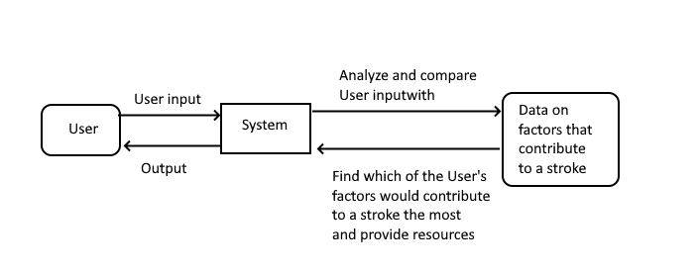

## **Product Functions/Features**

*The system will ask the user questions such as their age, living conditions, weight, and Body Mass Index for instance. The system will also display to the user their likelihood of having a stroke as well as ways the user can prevent the stroke based on which of their factors would contribute the most to the stroke.*

## **User Classes and Characteristics**

*The Users will be individuals who are either at risk of a stroke, study symptoms of a stroke, or have had a stroke in the past. They would want to use the system to either assist themselves in taking precautionary measures to prevent a stroke, if they are at risk, changing habits to prevent a stroke from occurring once more, as well as understanding different variables that cause strokes.*

## **Operating Environment**

*The actual final product will be able to work on most major platforms that are able to execute .exe files. Such products consist of Windows 7, Windows 10, Windows 11, Mac Operating System, and Linux. Able to run the actual program on both 32 and 64 bit operating platforms. Access to the internet would be a great asset for best prediction but not required.*

## **Design and Implementation Constraints**

*Constraints include timing, memory and storage requirements enough to perform calculations quickly as well as have the software installed. An internet connection is also required for the user to download the software.*

# **Functional Requirements**

*Translate product or system level requirements (e.g. documented elsewhere in product/system requirements documents) to the functions this software must perform, with a sub-paragraph for each function.*

## **System Features**

### Gather information from the user

#### ***Description and Priority***

*This feature will use existing patient information on their health data in order to predict new patient data. Without this dataset there would be no way to actually predict our results for the patients.*

#### ***Stimulus/Response Sequences***

*The user will have to input proper and up to date information into the system. The system should be able to predict results from 30 seconds to a minute if not more after utilizing all of the information. In exchange for this the system would store information on user to help further ML predictions for more patients.*

### Compare user’s information with common symptoms of a stroke

*Data Storage*

#### ***Description and Priority***

*This feature will take patient information that was entered and compare it with existing information about which symptoms contribute to a stroke more frequently.*

#### ***Stimulus/Response Sequences***

*The machine learning algorithm will compute the likelihood of the patient having a stroke based on every factor the patient input into the system. There will be a mathematical formula that will compute the percentage of likelihood*

### Display to the user their likelihood of having a stroke and preventions based on their provided information

***Data Manipulation***

#### ***3.1.3.1 Description and Priority***

*This feature will display the results from the machine learning computation and match which factors the user is at risk for a stroke with resources that can help prevent the stroke by stopping those risks.*

#### ***3.1.3.2 Stimulus/Response Sequences***

*This feature will display example resources if the user is not connected to the internet. Connecting to the internet will allow the system to dynamically find a specialist for the user based on their location and their need.*

#### 3.1.3.3 Functional Requirements

**REQ 1):** Ability for user to create an account

Users should create an account to be able to store their saved information from the prediction results and the ability to retake with new results at any time.

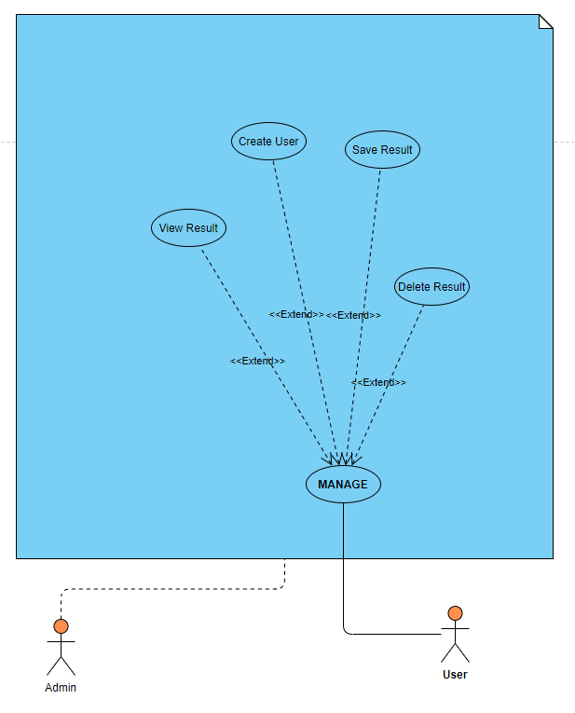

**REQ 2):** Supervised & Unsupervised Machine Learning (ML) for User Prediction

System must contain both Supervised and Unsupervised ML, and utilize **cross validation methods** in order to get the most accurate prediction possible.

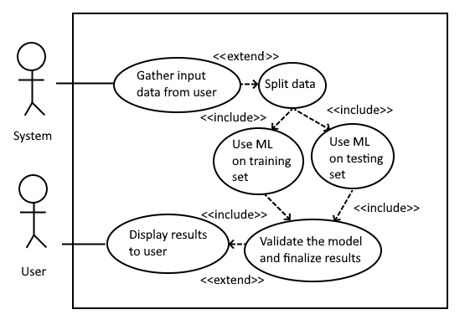

**REQ 3):** Questions as User Input

The system must ask questions to the user based on factors that cause strokes such as their height, weight, living conditions, Body Mass Index, and age to be able to determine the likelihood of a stroke. This is a functional requirement due to the questions being the basis of how the system operates, predicting if the user will have a stroke.

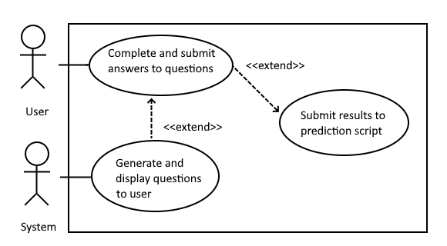

## **Preliminary Use Case Models and Sequence Diagrams**

### **Use Case Model**

#### 

### **Sequence Diagrams**

1. Create account

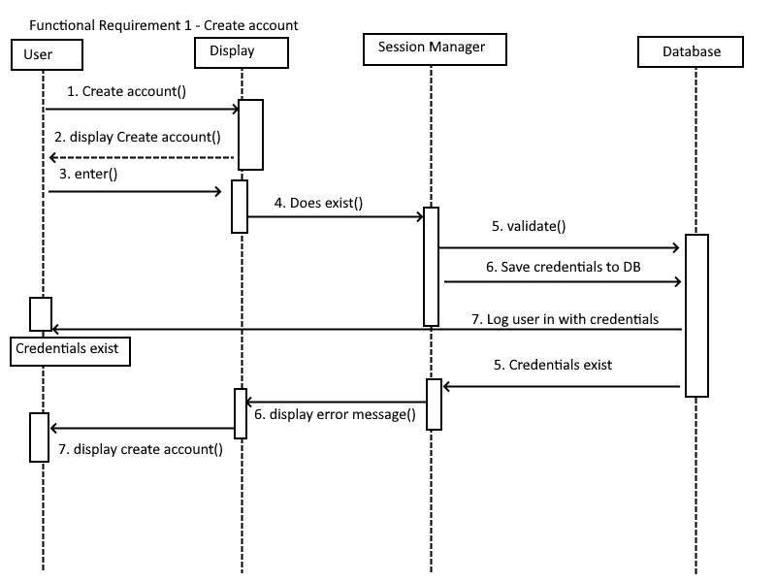

1. Login

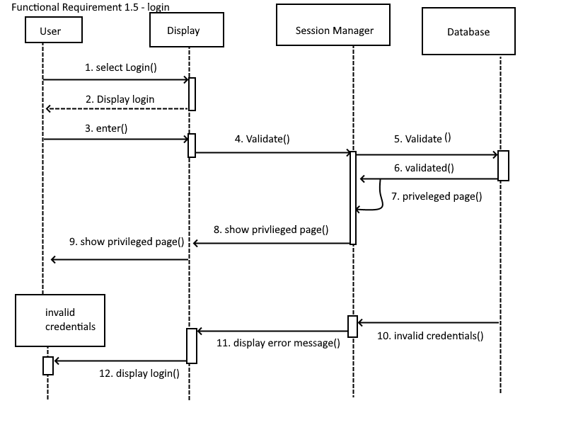

1. Questions as User Input

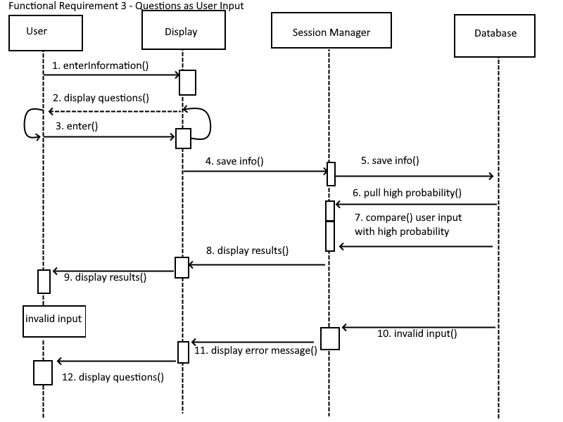

1. User Prediction

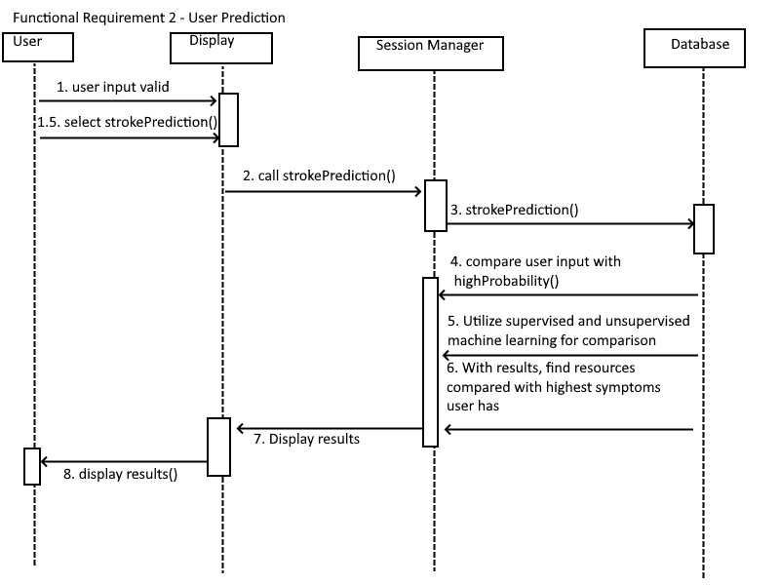

### Entity Relationship Diagram

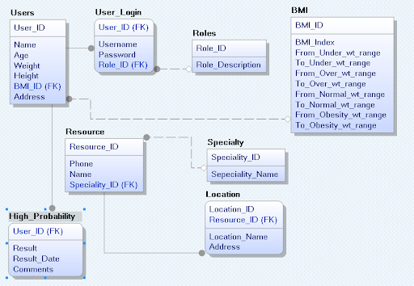

# **Nonfunctional Requirements**

## **Performance Requirements**

Windows 7 or later operating systems.

3500 MHz processor or higher

8GB RAM or higher

25 GB Available Hard Drive Space

## **Security Requirements**

*There must be a password protection in place before any other action can be done on the software. Data can still be collected before authentication, but order execution cannot. They must also be signed into their broker to allow order to go through*

Prior to using the system, the user must create or sign into their account. Creating an account will allow the user to save their data onto the system for future reference.

## **Usability Requirements**

*Users should understand how to download a program and connect to the internet. The system will be understandable enough for the user to figure out how to operate it. There will also be a user manual for their reference.*

## Software Quality Attributes

The system requires the user to fill in every field within the questionnaire to be able to determine the likelihood of a stroke. If a user does not fill in certain fields such as their weight, the system will not be able to accurately determine their likelihood of a stroke. The system must include an auto save feature after the user fills in a field within the form. This will make it convenient for the user in case they lose connection their data will be saved.

## System Requirements Installation of active working Python 3.7 or 3.9 and Anaconda library & Utilization of Python libraries such as; Matplotlib, Pandas, Numpy. Must possess an active and working installation of Python, also must have Anaconda library installed in order to further simplify the process. Proper utilization of matplotlib, pandas, numpy, and more data science pip installers must be processed in order to accurately go through the dataset to properly process the dataset and prepare for executable.

## **Reliability Requirements**

*Mean Time Between Failures (MTBF) — 1 year*

*Mean Time To Repair (MTTR)—5 hours*

*Accuracy—99.9%*

*Maximum Bugs or Defect Rate—1/KLOC*

## **Supportability Requirements**

*The system will be built upon a downloadable program file in a python base which will allow it to function on most computers as well as function with offline usage.*

## **Legal, Copyright, and Other Notices**

*This software will be completely open source and anyone can use it.*

## **External Interface Requirements**

### **User Interfaces**

### 

### **Hardware Interfaces**

*This software may connect to the internet either through wired or wireless methods. It can also be ran without an active internet source connection. However one is strongly recommended for best up to date results from the program.*

### **Software Interfaces**

*This project will be utilizing python to demonstrate the user interface and display information. Pycharm and or Spyder as an IDE for Python and the use of Auto-to-Py for conversation into the executable file.*

### **Communications Interfaces**

*This software will use python and SQL to communicate between the stored data, machine learning algorithm, and user input.*

## **On-Line User Documentation and Help System Requirements**

*Any User who needs Documentation will be referred to a website which will explain how to operate the system*

## 

**Appendix A: Glossary**

| **Term** | **Definition** |
| --- | --- |
|  |  |
|  |  |
|  |  |
|  |  |
|  |  |

**Appendix B: Analysis Models**

**Appendix C: To Be Determined List**

*TBD eternal application for which the database will be managed.*